Experiment 8: String and Wrapper Classes

Name: Aditya Goyat

SAP ID: 500080575

1) Write a program for searching strings for the first occurrence of a character or substring and for the last occurrence of a character or substring.

CODE:

**package** exp8;

**import** java.util.*;

**public** **class** MainQ1 {

**int** nonRepeat(String s) {

**int** index = -1;

**char** arr[] = **new** **char**[256];

**for**(**int** i = 0; i < s.length(); i++)

arr[s.charAt(i)]++;

**for**(**int** i = 0; i < s.length(); i++) {

**if**(arr[s.charAt(i)] == 1) {

index = i;

**break**;

}

}

**return** index;

}

**public** **static** **void** main(String args[]) {

Scanner sc = **new** Scanner(System.***in***);

MainQ1 obj = **new** MainQ1();

String s;

System.***out***.print("Enter the string: ");

s = sc.nextLine();

**int** index = obj.nonRepeat(s);

**if**(index == -1)

System.***out***.println("There is no non repeating character in the string!");

**else**

System.***out***.println("The first non repeating charater is: " + s.charAt(index));

}

}

OUTPUT:

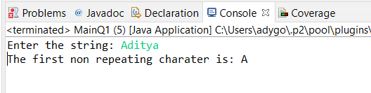

2) Write a program that converts all characters of a string in capital letters. (Use StringBuffer to store a string). Don’t use inbuilt function.

CODE:  
**package** exp8;

**import** java.util.*;

**public** **class** MainQ2 {

**public** **static** **void** main(String[] args) {

// **TODO** Auto-generated method stub

Scanner sc = **new** Scanner(System.***in***);

StringBuffer str = **new** StringBuffer();

String s = sc.nextLine();

str.append(s);

**for**(**int** i = 0; i < str.length(); i++) {

**if**(str.charAt(i) >= 'a' && str.charAt(i) <= 'z') {

**char** c = str.charAt(i);

c = (**char**)((**int**)c - 32);

str.setCharAt(i, c);

}

}

System.***out***.println(str);

sc.close();

}

}

OUTPUT:

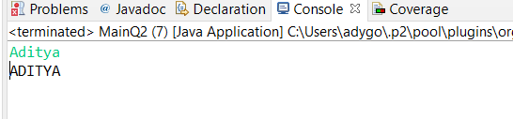

3) Write a program in Java to read a statement from console, convert it into upper case and again print on console. (Don’t use inbuilt function)

CODE:

**package** exp8;

**public** **class** MainQ3 {

**public** **static** **void** main(String[] args) {

// **TODO** Auto-generated method stub

StringBuffer str = **new** StringBuffer();

str.append(args[0]);

**for**(**int** i = 0; i < str.length(); i++) {

**if**(str.charAt(i) >= 'a' && str.charAt(i) <= 'z') {

**char** c = str.charAt(i);

c = (**char**)((**int**)c - 32);

str.setCharAt(i, c);

}

}

System.***out***.println(str);

}

}

OUTPUT:

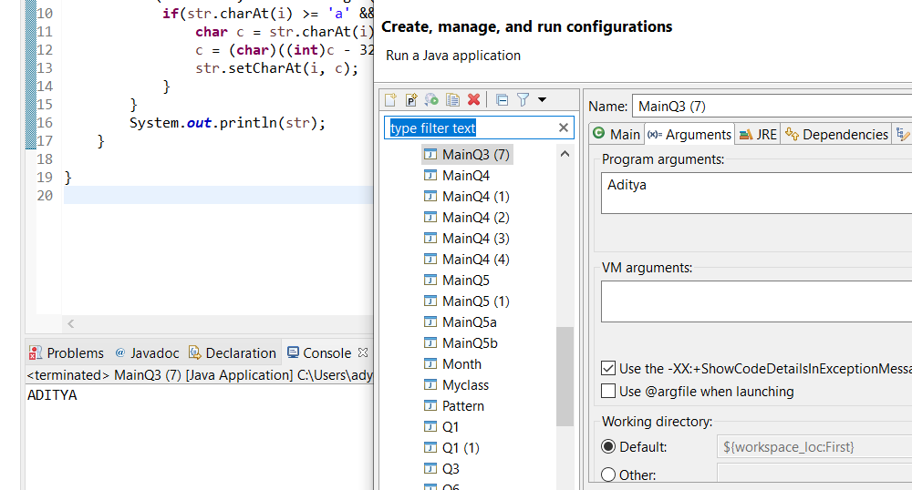

4) Write a program in Java to create a String object. Initialize this object with your name. Find the length of your name using the appropriate String method. Find whether the character ‘a’ is in your name or not; if yes find the number of times ‘a’ appears in your name. Print locations of occurrences of ‘a’ .Try the same for different String objects

CODE:

**package** exp8;

**import** java.util.*;

**public** **class** MainQ4 {

**public** **static** **void** main(String[] args) {

// **TODO** Auto-generated method stub

**int** counter = 0;

Scanner sc = **new** Scanner(System.***in***);

String s = sc.nextLine();

String str = **new** String(s);

StringBuilder result = **new** StringBuilder();

**for**(**int** i = 0; i < str.length(); i++) {

**if**(str.charAt(i) == 'a') {

counter++;

result.append(i + " ");

}

}

**if**(counter != 0) {

System.***out***.println("Yes, the character a is present in the string.");

System.***out***.println("Number of occurences = " + counter);

System.***out***.println("The index of occurences = " + result);

}

**else** {

System.***out***.println("No, the character a is not present in the string.");

}

}

}

OUTPUT:

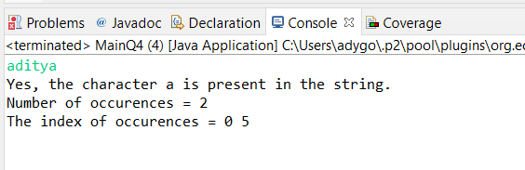

5) Write a Java code that converts int to Integer, converts Integer to String, converts String to int, converts int to String, converts String to Integer converts Integer to int.

CODE:

**package** exp8;

**public** **class** MainQ5 {

**public** **static** **void** main(String[] args) {

// **TODO** Auto-generated method stub

**int** a = 10;

System.***out***.println("The int value is: " + a);

Integer inta = Integer.*valueOf*(a);

System.***out***.println("Successfully converted int to Integer");

String s = Integer.*toString*(inta);

System.***out***.println("Successfully converted Integer to String");

**int** b = Integer.*parseInt*(s);

System.***out***.println("Successfully converted String to int");

String s2 = String.*valueOf*(b);

System.***out***.println("Successfully converted int to String");

Integer a2 = Integer.*valueOf*(s2);

System.***out***.println("Successfully converted String to Integer");

**int** a3 = a2.intValue();

System.***out***.println("Successfully converted Integer to int");

}

}

OUTPUT:

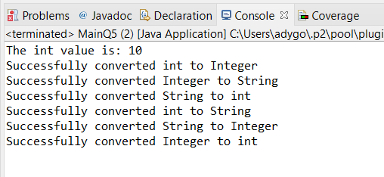

7) Write a Java code that converts float to Float converts Float to String converts String to float converts float to String converts String to Float converts Float to float.

CODE:

**package** exp8;

**public** **class** MainQ6 {

**public** **static** **void** main(String[] args) {

// **TODO** Auto-generated method stub

**float** f = 10f;

Float f1 = Float.*valueOf*(f);

System.***out***.println("Successfully converted float to Float");

String s = String.*valueOf*(f1);

System.***out***.println("Successfully converted Float to String");

**float** f2 = Float.*parseFloat*(s);

System.***out***.println("Successfully converted String to float");

String s2 = String.*valueOf*(f2);

System.***out***.println("Successfully converted float to String");

Float f3 = Float.*valueOf*(s2);

System.***out***.println("Successfully converted String to Float");

**float** f4 = f3.floatValue();

System.***out***.println("Successfully converted Float to float");

}

}

OUTPUT:

